

Lab 14
  - User Defined Variables using Structures

https://github.com/mmujtaba25/cs-110

Muhammad Mujtaba
CMD ID: 540040
mmujtaba.bese25seecs@seecs.edu.pk

  - Class: BESE 16B
  - Batch: 2k25

Task 1: [CLO2]

CODE
#include <iostream>

struct Point
{
double x;
double y;
};

int main()
{
Point p1 = {3.0, 4.0};
Point p2 = {6.0, 8.0};

double distance = std::sqrt((p2.x - p1.x) * (p2.x - p1.x) + (p2.y - p1.y) * (p2.y - p1.y));

std::cout << "Point 1: (" << p1.x << ", " << p1.y << ")\n";
std::cout << "Point 2: (" << p2.x << ", " << p2.y << ")\n";
std::cout << "Distance between points: " << distance << std::endl;

return 0;
}

OUTPUT
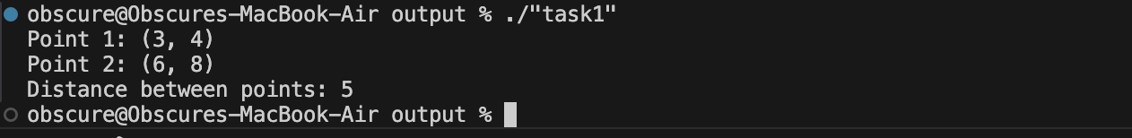

Task 2: [CLO 2]

CODE
#include <iostream>

struct Clock
{
int hours;
int minutes;
int seconds;
};

int main()
{
Clock time;

std::cout << "Enter -1 to exit at any time." << std::endl;
std::string input = "0";
while (std::stoi(input) != -1)
{
std::cout << "Enter hours: ";
std::cin >> input;
if (std::stoi(input) == -1)
break;
time.hours = std::stoi(input);
if (time.hours < 0 || time.hours > 23)
{
std::cout << "Invalid hours. Please enter a value between 0 and 23." << std::endl;
continue;
}

std::cout << "Enter minutes: ";
std::cin >> input;
if (std::stoi(input) == -1)
break;
time.minutes = std::stoi(input);
if (time.minutes < 0 || time.minutes > 59)
{
std::cout << "Invalid minutes. Please enter a value between 0 and 59." << std::endl;
continue;
}

std::cout << "Enter seconds: ";
std::cin >> input;
if (std::stoi(input) == -1)
break;
time.seconds = std::stoi(input);
if (time.seconds < 0 || time.seconds > 59)
{
std::cout << "Invalid seconds. Please enter a value between 0 and 59." << std::endl;
continue;
}

std::cout << "Time: " << time.hours << ":" << time.minutes << ":" << time.seconds << std::endl;
}

std::cout << "Exiting program." << std::endl;

return 0;
}

OUTPUT
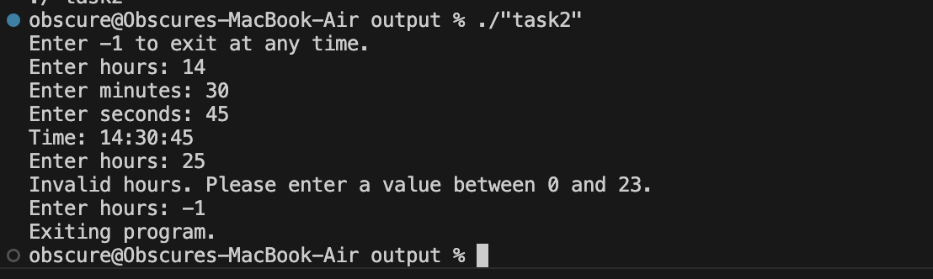

Task 3: [CLO 3]

CODE
#include <iostream>

struct Student
{
std::string name;
int rollNumber;
float marks;
};

int main()
{
Student students[3];
float totalMarks = 0;

for (int i = 0; i < 3; ++i)
{
std::cout << "Enter name for student " << i + 1 << ": ";
std::cin >> students[i].name;

std::cout << "Enter roll number: ";
std::cin >> students[i].rollNumber;

std::cout << "Enter marks: ";
std::cin >> students[i].marks;

totalMarks += students[i].marks;
}

float averageMarks = totalMarks / 3;
std::cout << "Class average marks: " << averageMarks << std::endl;

return 0;
}

OUTPUT
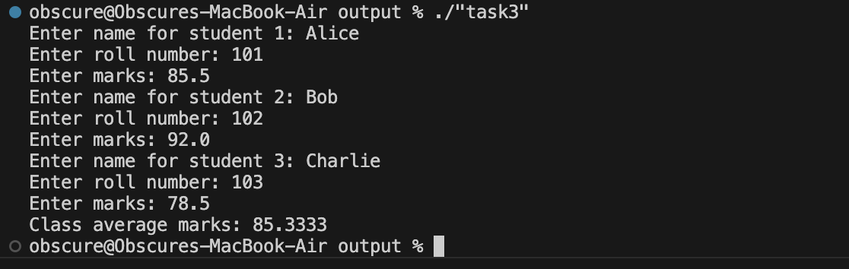

Task 4: [CLO 3]

CODE
#include <iostream>

struct Book
{
char title[50];
char author[30];
int year;
float price;
};

bool isValidBook(const Book &b)
{
// check year
if (b.year < 1900 || b.year > 2023)
return false;
// check price
if (b.price <= 0)
return false;
// check title
if (b.title[0] == '\0') // for char array, it ends when it reaches null character
return false;
return true;
}

int main()
{
Book book;

std::cout << "Enter book title: ";
std::cin.getline(book.title, 50);

std::cout << "Enter author name: ";
std::cin.getline(book.author, 30);

std::cout << "Enter publication year: ";
std::cin >> book.year;

std::cout << "Enter price: ";
std::cin >> book.price;

if (isValidBook(book))
{
std::cout << "Valid Book" << std::endl;
std::cout << "Title: " << book.title << std::endl;
std::cout << "Author: " << book.author << std::endl;
std::cout << "Year: " << book.year << std::endl;
std::cout << "Price: " << book.price << std::endl;
}
else
{
std::cout << "Invalid Book" << std::endl;
}

return 0;
}

OUTPUT
